SIYA ADMIN PANEL
Documentation
Reference Document | Version 1.0

1. Introduction
This document provides a comprehensive overview of the NYK platform demonstration, highlighting the key functionalities and access levels available within the system.

Organization Type
When assigning a user to an organization, the available options depend on the Ship Management setting of that organization. In the system, an organization represents a company and is created with details such as the company name and registered address.

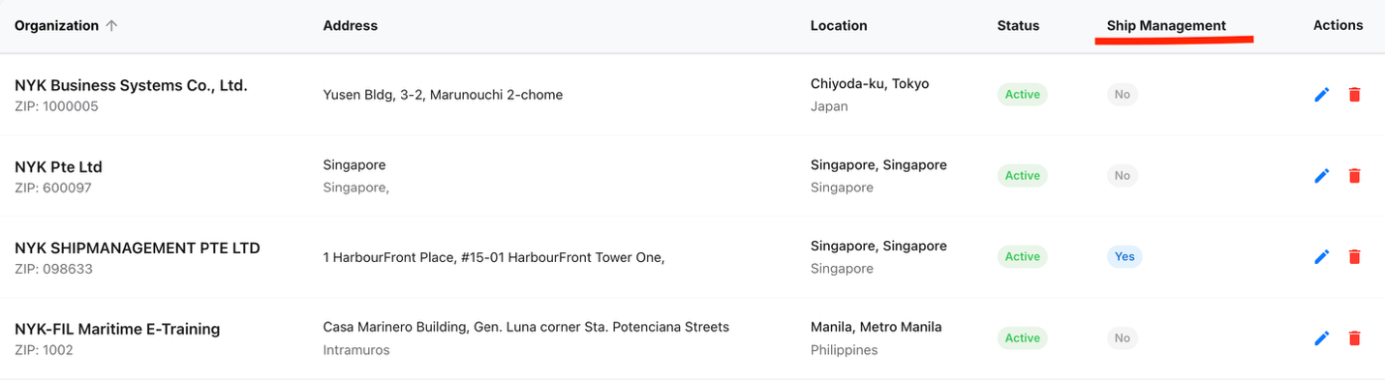

The platform supports two main types of organization:
- Ship Management
- Non-Ship Management

Ship Management Setting | Behaviour
Ship Management = Yes | Only Fleets will be available. Select the applicable/specific fleet(s) or choose the company level to provision all organization vessels.
Ship Management = No | Only Groups will be available. Select the applicable group(s) from the list.
This setup ensures that user access is aligned with the organization’s structure.
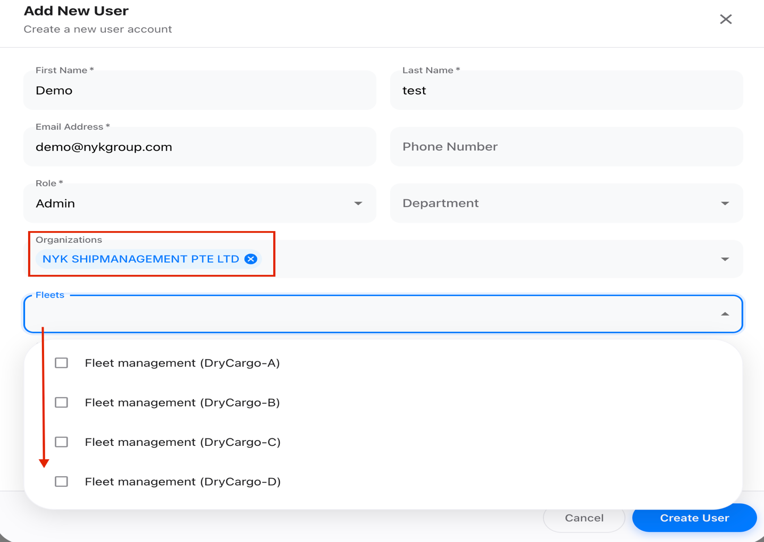
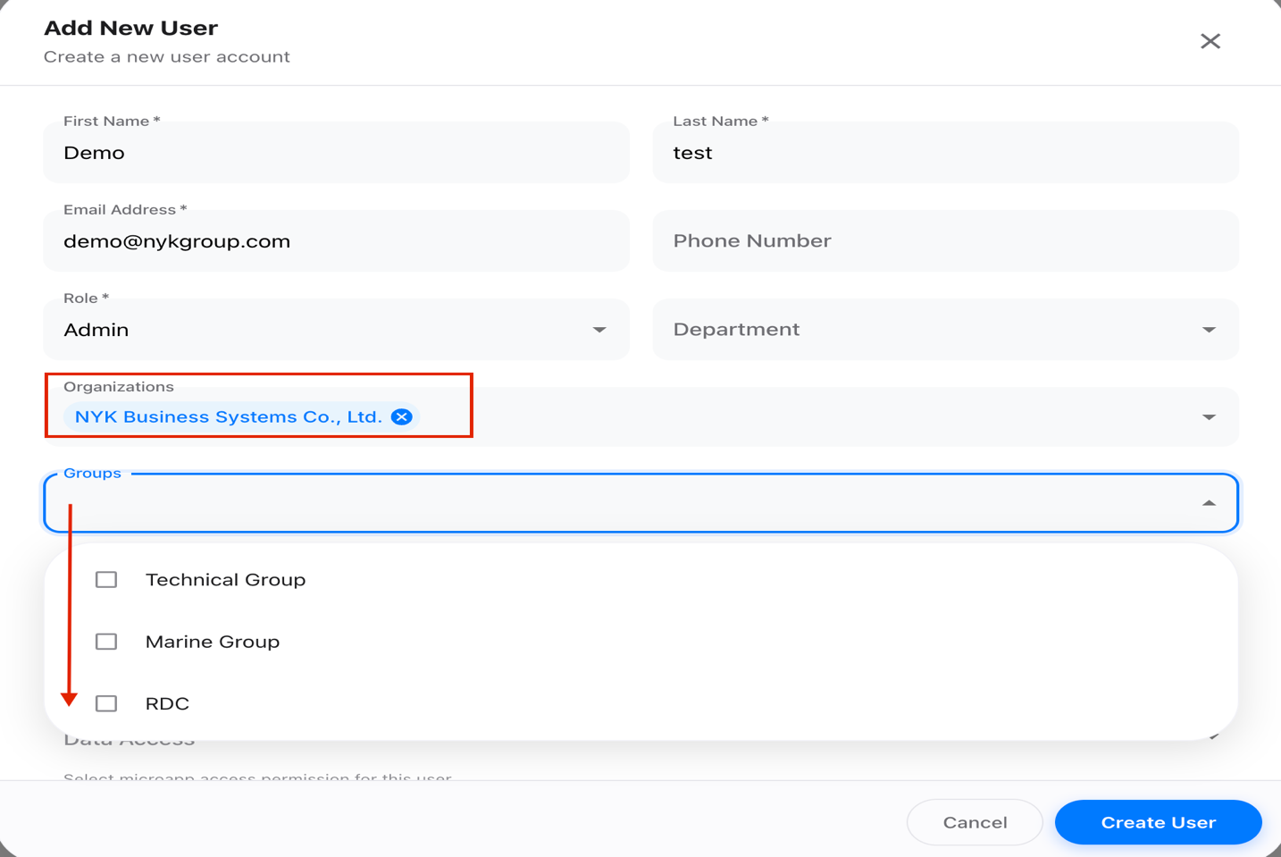

User Access Levels
Each user is assigned a different access within the system based on their organization type:
- Data Access
- Document Access

1.2.1 Data Access
When we create a new user , we need to select microapp access permission for this user in Data access field.
Data Access is determined by the organization's Ship Management configuration setup:
- If Ship Management = Yes: Fleet-level access and Company-level access are available.
- If fleets are selected, the user will have Fleet-level access.
- If no fleets are selected and Company-level access is chosen under Data Access, the user will have Company-level access.
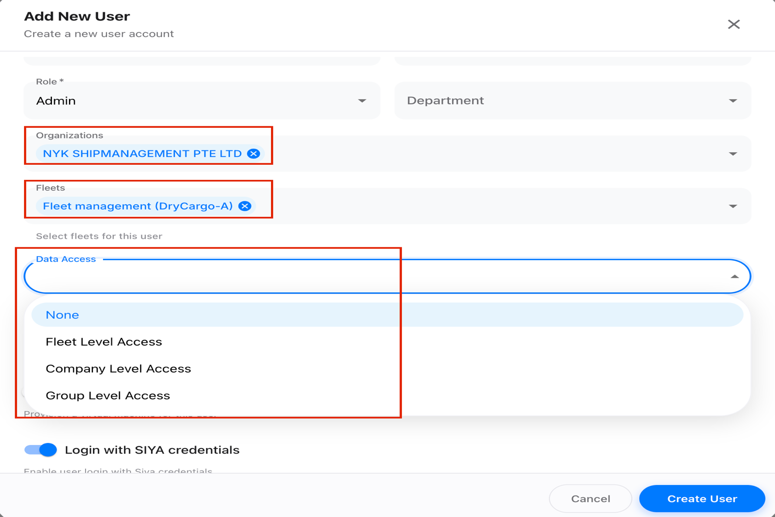

- If Ship Management = No: Only Group-level access will be available.
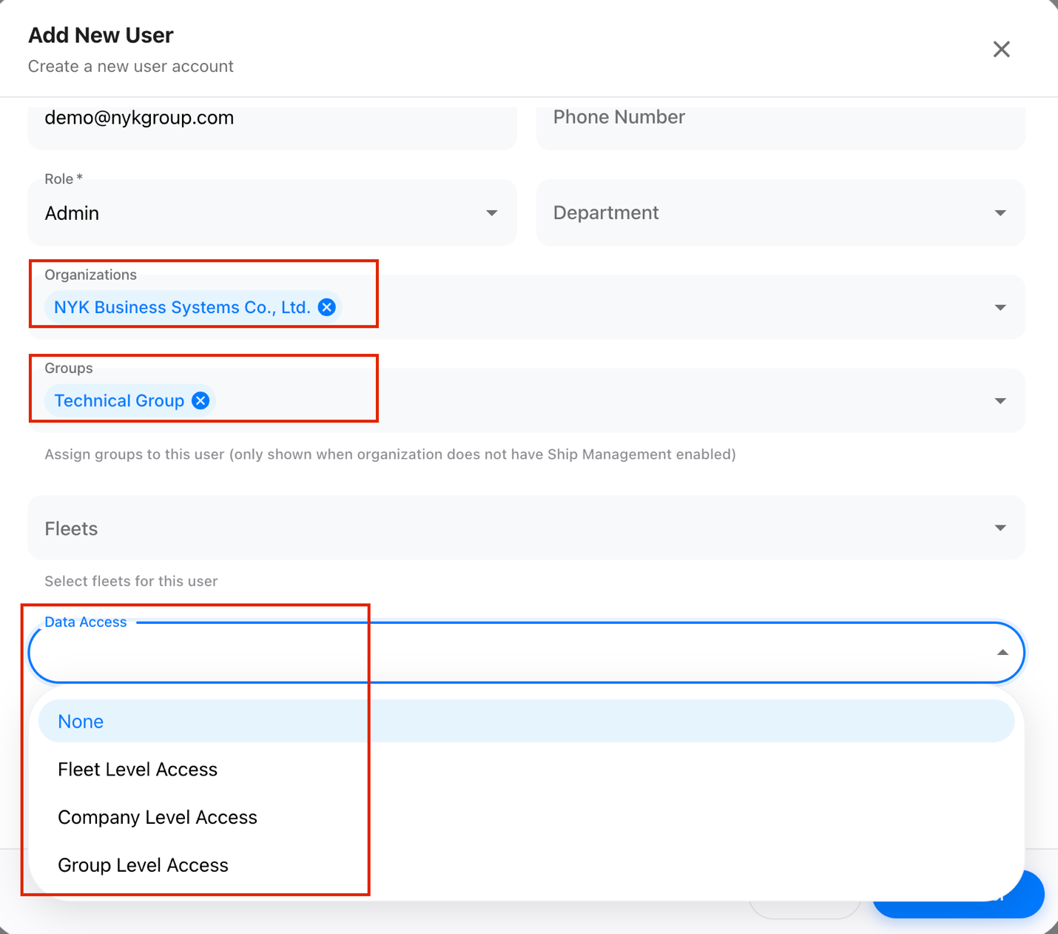

Access Level | Description
Company Level | Access to all fleets and groups within the company.
Fleet Level | Access restricted to specific fleets under the company.
Group Level | Access limited to specific vessel groups.

This access control ensures that users can only view and manage the vessels and data relevant to their level of access.

1.2.2 Document Access
Document access is intended for Vessel Karte. The applicable MCP server module access is provided based on the specific MCP server to which the user has been granted access.
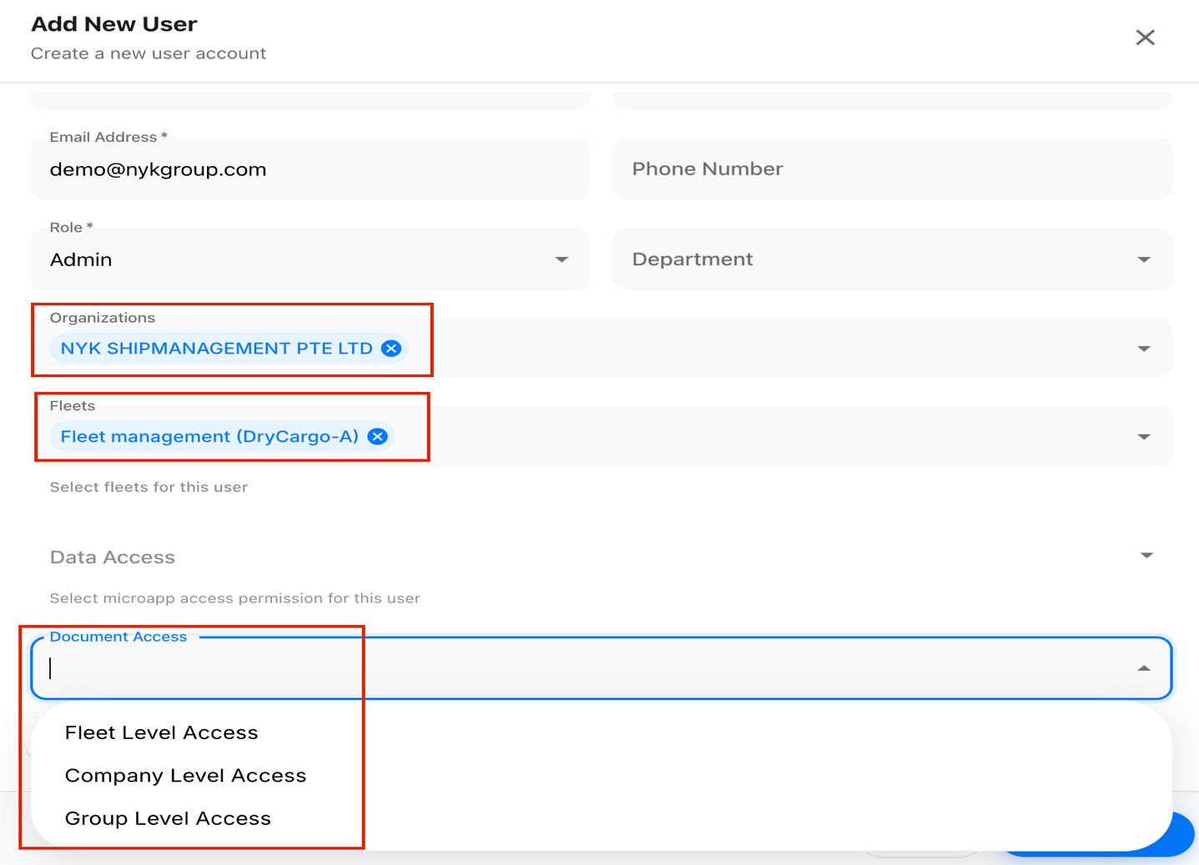

Access Level | Description
Company Level | Access to all fleets and groups within the company.
Fleet Level | Access restricted to specific fleets under the company.
Group Level | Access limited to specific vessel groups.

VM Machine Toggle
The VM (Virtual Machine) toggle controls the user's landing experience upon login:

VM State | User Landing Experience
VM = ON | Creates a new machine for the user and navigates to the chat landing page.
VM = OFF | User is directed to the specific application modules: Micro Apps, Case Files, Data Insights, and Documents.

The Virtual Machine (VM) availability depends on whether the feature is enabled or disabled for the respective user.

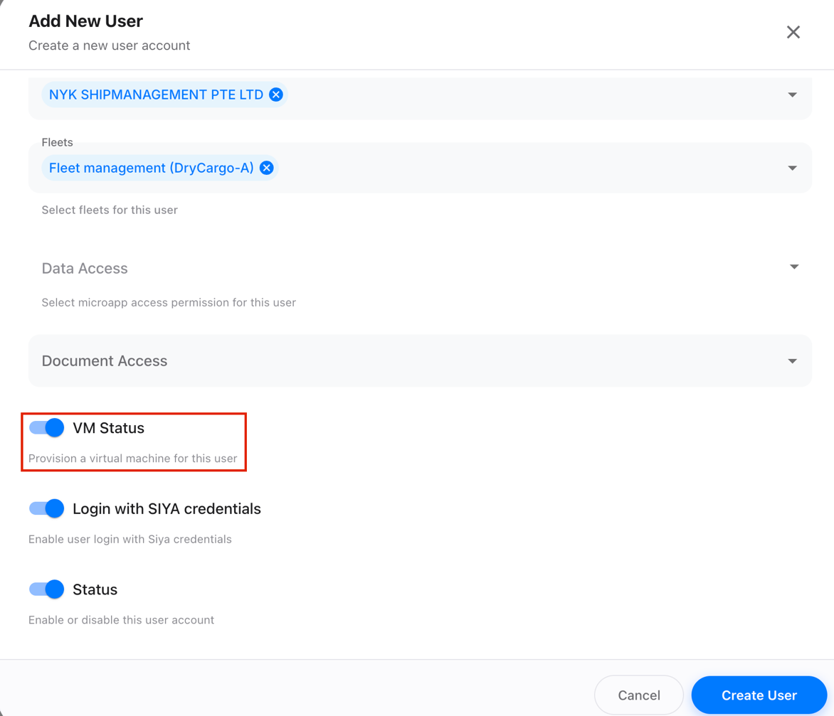

Expected Result: VM functionality is available, allowing the administrator to manage the VM state (On / Off) per user.

2. Procedure
The following steps demonstrate the standard workflow for setting up and configuring the NYK platform as an administrator.

Step 1: Login with Admin Credentials
- Open the admin login page: https://app.siya-ai.com/admin/
- Enter the admin username and password.
- Click the Sign In button.
- Upon successful authentication, the user will be redirected to the admin dashboard page.
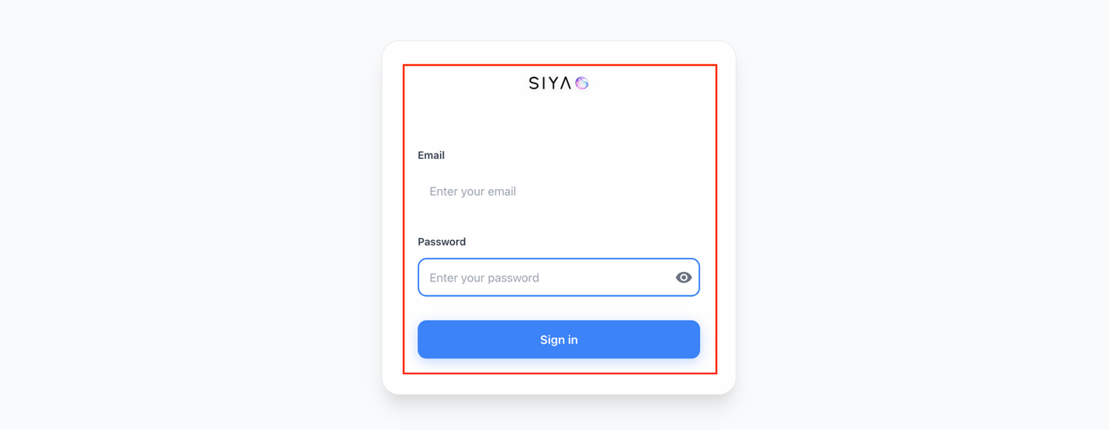

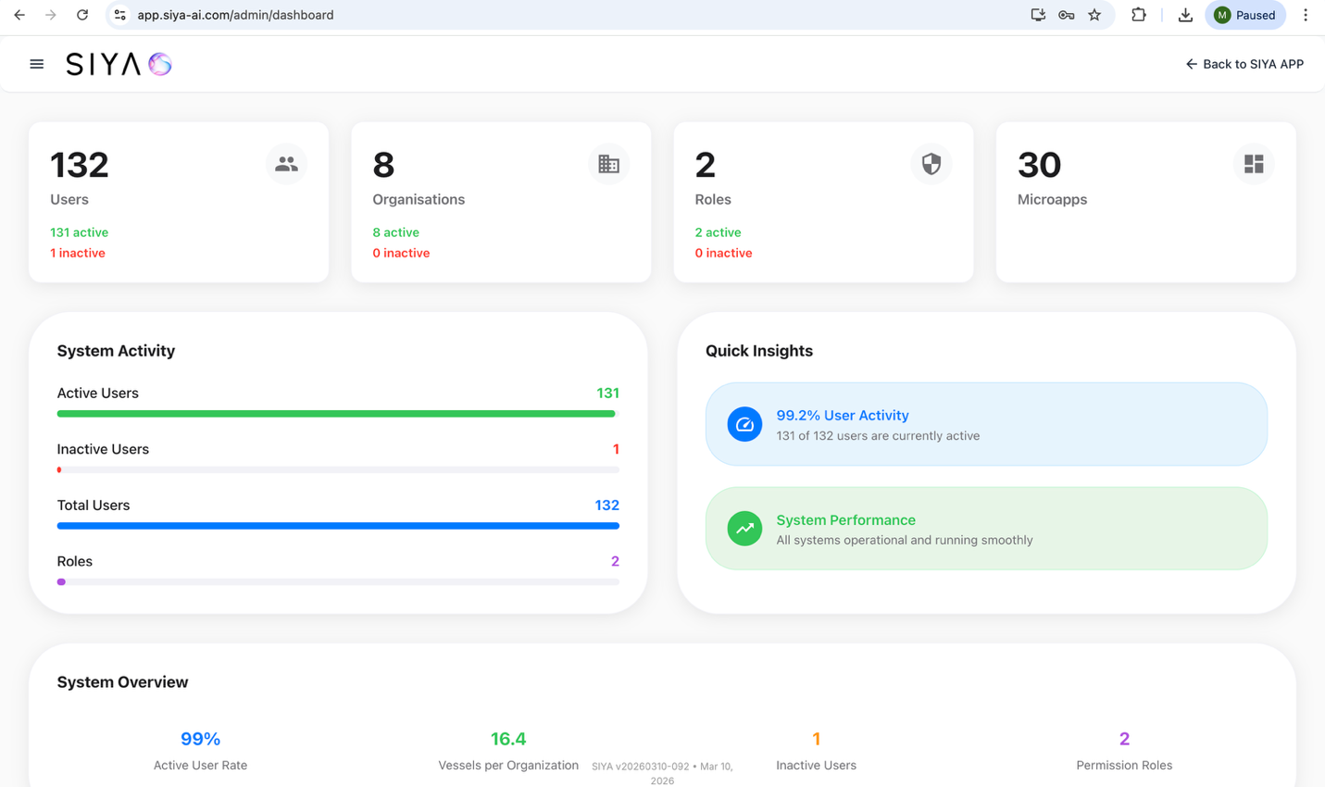

Expected Result: The admin user successfully logs into the system and gains access to all available modules and configurations.

Step 2: Create Organization
- Navigate to the Organization tab.
- Click Add Organization.
- Enter the required organization details:

Name | Name of the organization.
Address | The organization's registered address.
Active Status (Y/N) | Indicates whether the organization is active in the system.
Ship Management (Y/N) | Specifies whether the organization belongs to ship management.

- Click Add Organization to register the organization in the system.

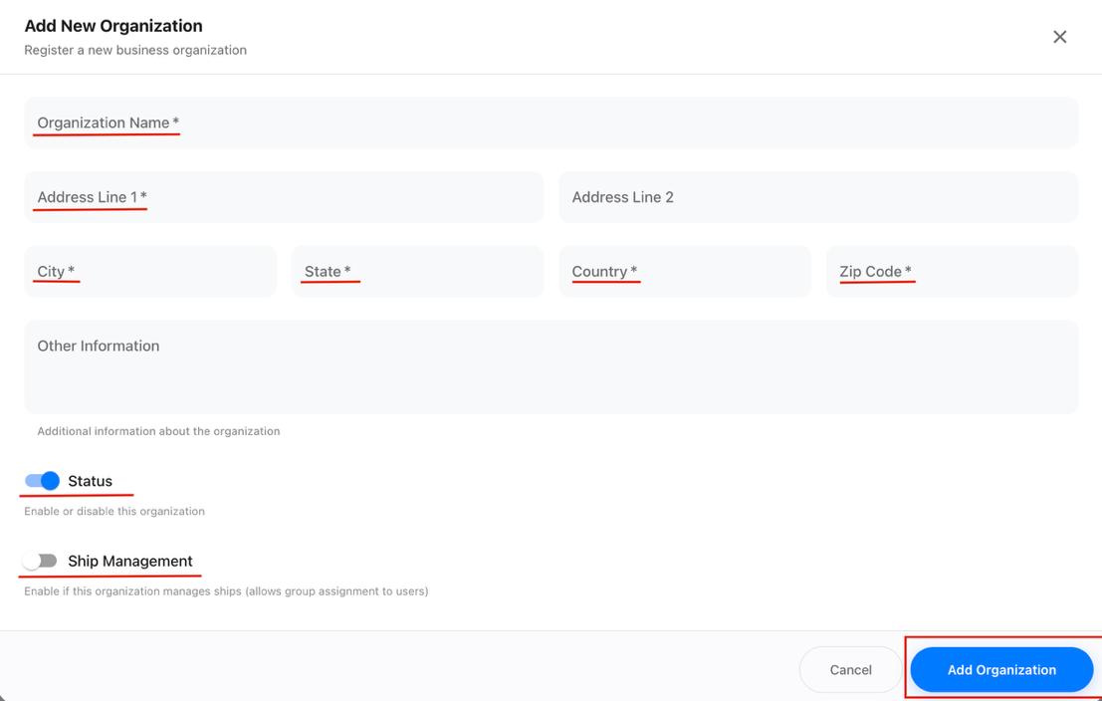

Expected Result: A new organization is successfully created and becomes available for assigning fleets, groups, fleet distribution (vessels), and users.

Step 3: Create Fleet
- Navigate to the Fleet tab.
- Click Add Fleet.
- Enter the required fleet details:

Name | Name of the fleet.
Organizations | The registered organization(s) to associate with this fleet.

- Click Create Fleet to complete the configuration.

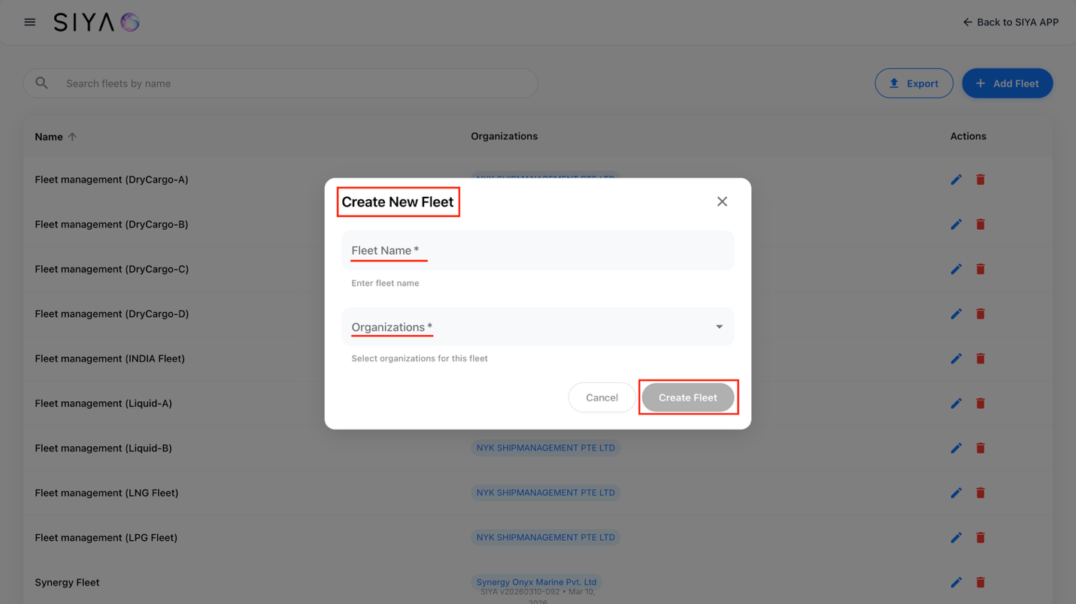

Expected Result: The fleet is successfully created for the selected organization, and the associated vessels are mapped under the respective fleet.

Step 4: Create Group
- Navigate to the Group tab.
- Click Add Group.
- Enter the Group Name.
- Click Add Group to complete the group creation.

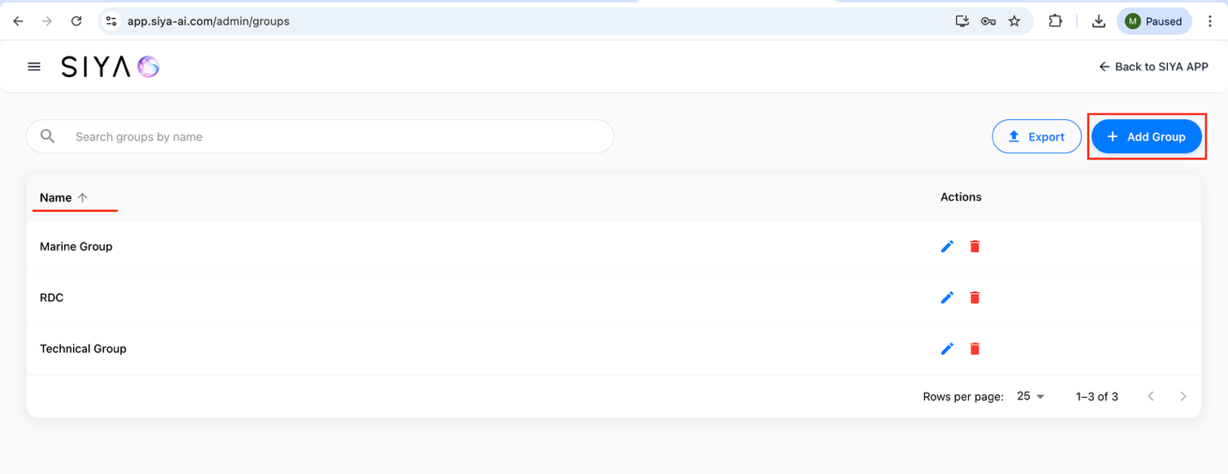

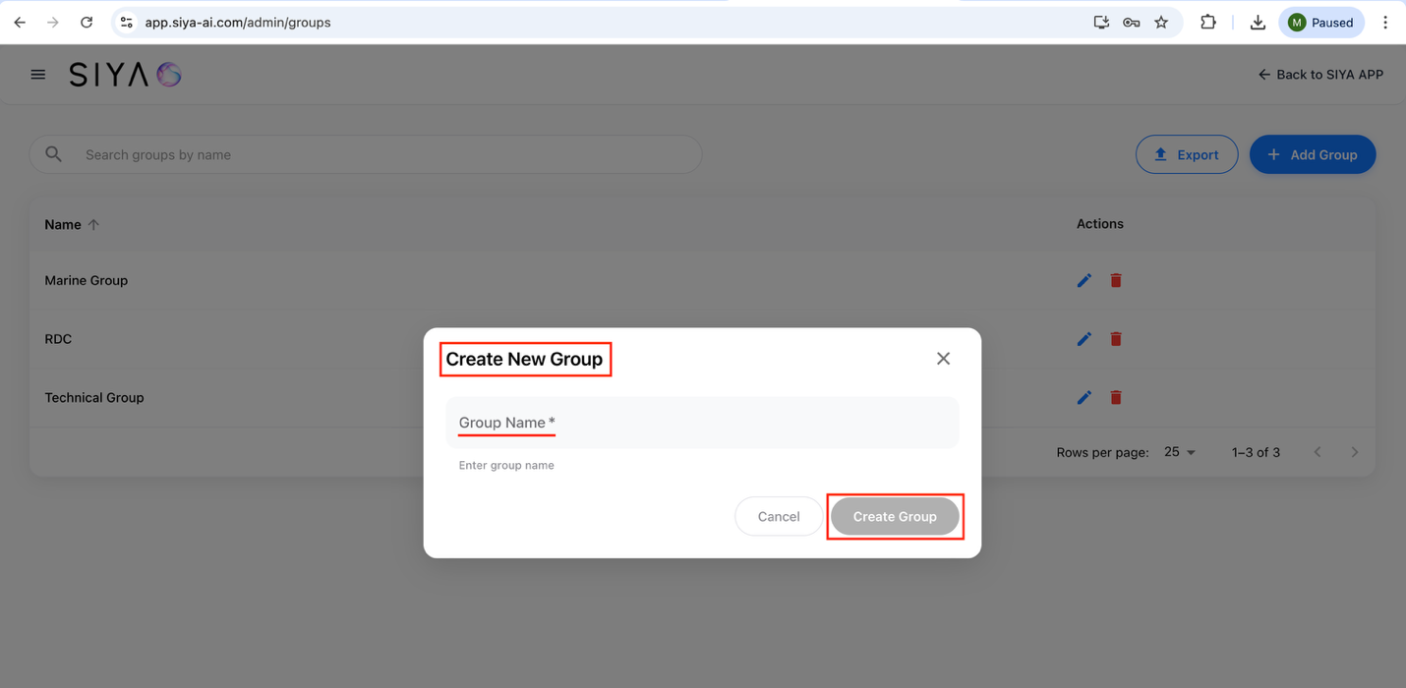

Expected Result: The group is successfully created and available for user assignment.

Step 5: Create User
- Navigate to the User tab.
- Click Add User.
- In the Add New User form, enter the required user details:
First Name | User's first name.
Last Name | User's last name.
Email Address | User's email address.
Role | The role assigned to the user.
Organizations | The organization the user belongs to.
Fleets | The fleets the organization belongs to.
Data Access | Configure Microapps permissions for this user's data access.
Document Access | Configure Vessel Karte access depends on the MCP server modules granted to the user.
VM Status | Creates a new machine when the user logs in (ON/OFF)
Login with SIYA credentials | Enable the flag if the user needs to log in using Microsoft credentials
Status | Enable or disable this user account

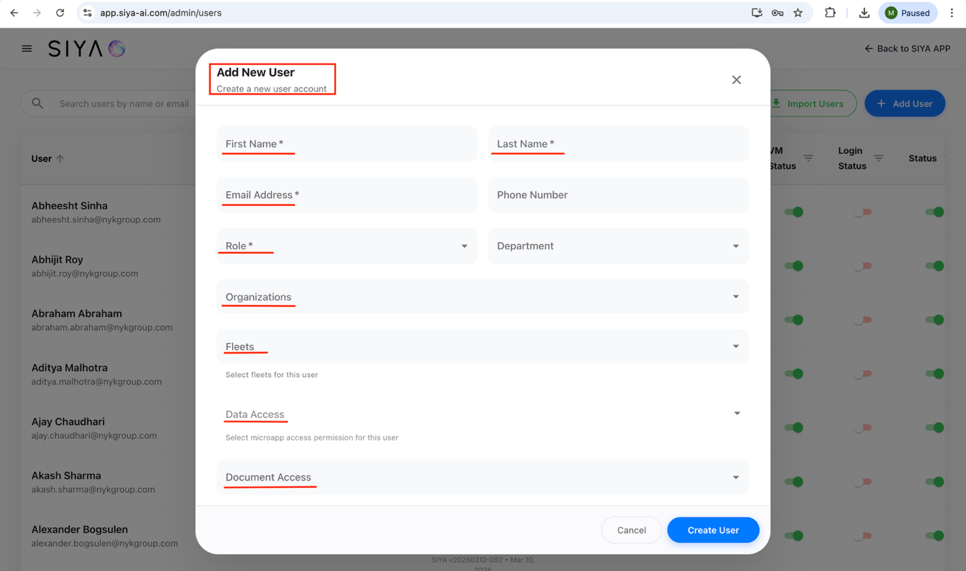

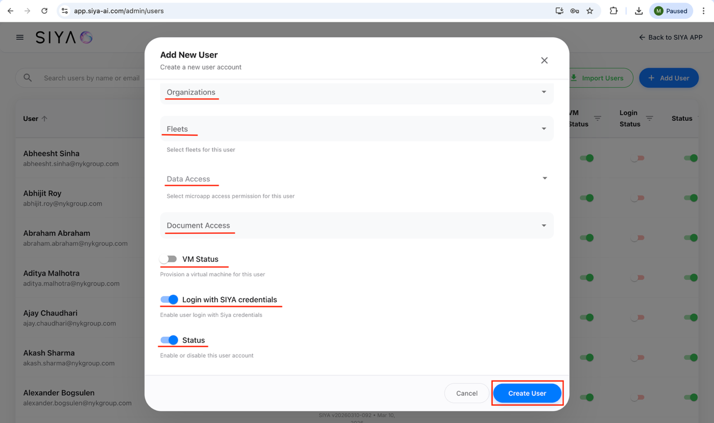

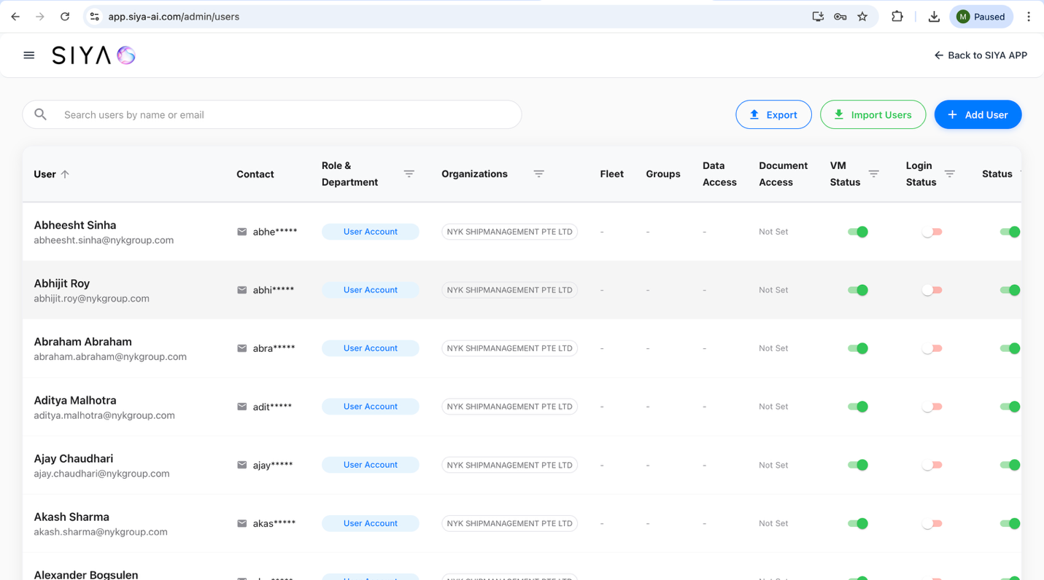

Expected Result: The user is successfully created and available in user list.

Step 6: Microapps Access Configuration
- Navigate to the Admin Panel.
- Open the Microapps tab.

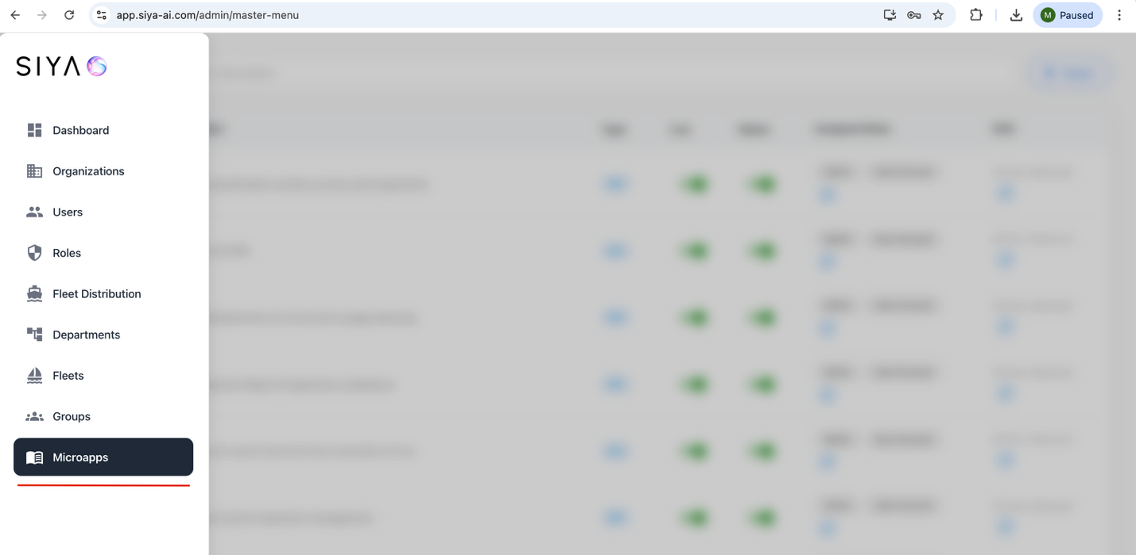

6.1 Role-Based Menu / List Configuration for Microapps
- Select and assign the relevant data from the list and assign the appropriate roles.
- Each role in the system has specific data access permissions configured here.
- The admin can review which Microapps data are accessible for a particular role.
- If required, the admin can modify the access permissions accordingly.

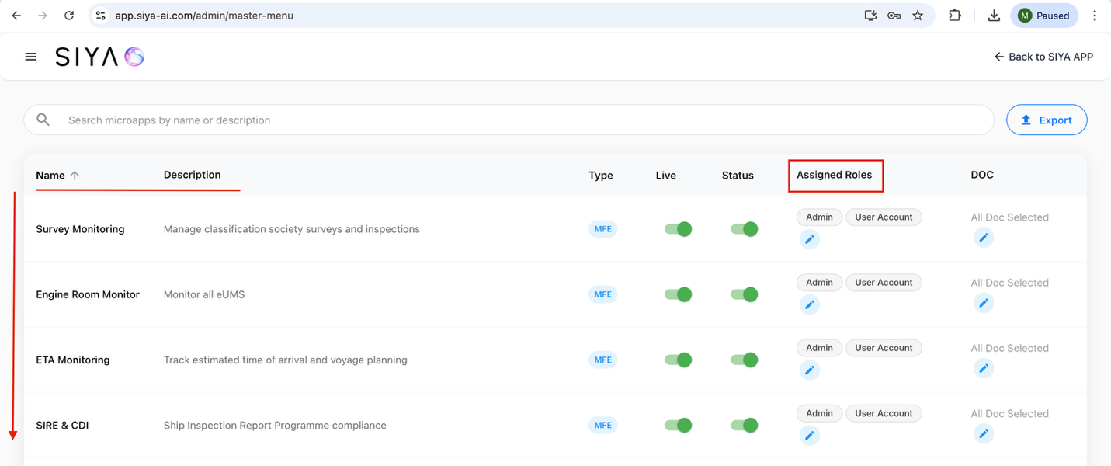

Expected Result: Users will only see the menus/lists of data in the Microapps that are assigned to their respective roles. Each user with an assigned role will have access to the corresponding data as configured by the administrator.

6.2 Login with Admin Credentials - Microapps
- Open the admin login page: https://app.siya-ai.com/admin/
- Enter the username and password.
- Click the Sign In button.
- Upon successful authentication, the user will be redirected to the admin dashboard page.
- Select Microapps tab
- View all the details of particular menu’s
- Login with user credentials and check whether the respective user have same menu’s under microapps.

Important Note
Microapps data access visibility is Role-based, not User-based. The admin can verify and control which Microapps-related data should be accessible for each role in the system. Users will only see the menus and lists in the Microapps that are assigned to their respective roles.

